Week 14 Individual Logbook
Capstone project
Matt Baker
2026
Table of Contents
Hours Breakdown 2
Completed Content/Documentation 3
Team Meetings 3
Advisor Meetings 3
Client Meetings 4
Research 4
Documentation 4
Testing 12
Development 15

Hours Breakdown
Category | Hours completed
Team meetings | 2hrs
Client meetings
Advisor meetings | 3hrs
Research | 1hr 30min
Development | 2hrs 30min
Testing | 1hr 30min
Documentation | 18hrs 45min
Logbook preparation | 1hr
Sick leave/specific conditions
Other
Total Hours for this week | 30hrs 15 min
Running total of hours completed for  Capstone | 339hrs 15min/450hrs

Completed Content/Documentation

Team Meetings
Monday, 12 October
10:00 – 11:00AM (1hr)
Team meeting going through every remaining descriptor, individual closeout, client closeout. academic closeout. Assigning work to each of these, I will generate the shared documents.
Advisor Meetings
Monday, 12 October
9:00 – 10:00AM (1hr)
Meeting with Bryce with all present, discussing methods of working with data, progress on data extraction/recording, working in industry, nature of research projects and passing on knowledge pre-conclusion, lessons learned. Various academic documents due. PC cleaning, GPU benchmarking.

Client Meetings

Research

Documentation
Monday, 12 October
11:00 – 12:30 (1hr 30min)
Recording metrics from the four-prompt Wireshark solution to compare:

4-Prompt Chunk Wireshark LLM Augmentation
This table records metrics gathered during LLM report generation for Wireshark data (packet captures) with chunk prompting into four sections. All figures are averages (mean).
Input Data | Test | Time (s) | Input Tokens | Output Tokens | Total Tokens | GPU 1 VRAM (MiB) | GPU 2 VRAM (MiB) | GPU 1 Power (W) | GPU 2 Power (W)
evidence01.pcap | 1 | 150.80 | 44385 | 3765 | 48150
evidence01.pcap | 2 | 71.83 | 44492 | 3967 | 48459
evidence01.pcap | 3 | 67.50 | 44492 | 3968 | 48460
evidence02.pcapng | 1 | 165.76 | 67162 | 4140 | 71302
evidence02.pcapng | 2 | 77.92 | 67246 | 4213 | 71459
evidence02.pcapng | 3 | 74.79 | 67246 | 4281 | 71527
evidence03.pcap | 1 | 190.00 | 67188 | 4038 | 71226
evidence03.pcap | 2 | 83.77 | 67513 | 4415 | 71928
evidence03.pcap | 3 | 75.64 | 67513 | 4340 | 71853

My setup, ssh terminal one (1) executes the LLM-augmentation scripts, terminal two (2) runs the Nvidia smi metric recording script, and terminal three (3) monitors the script output.
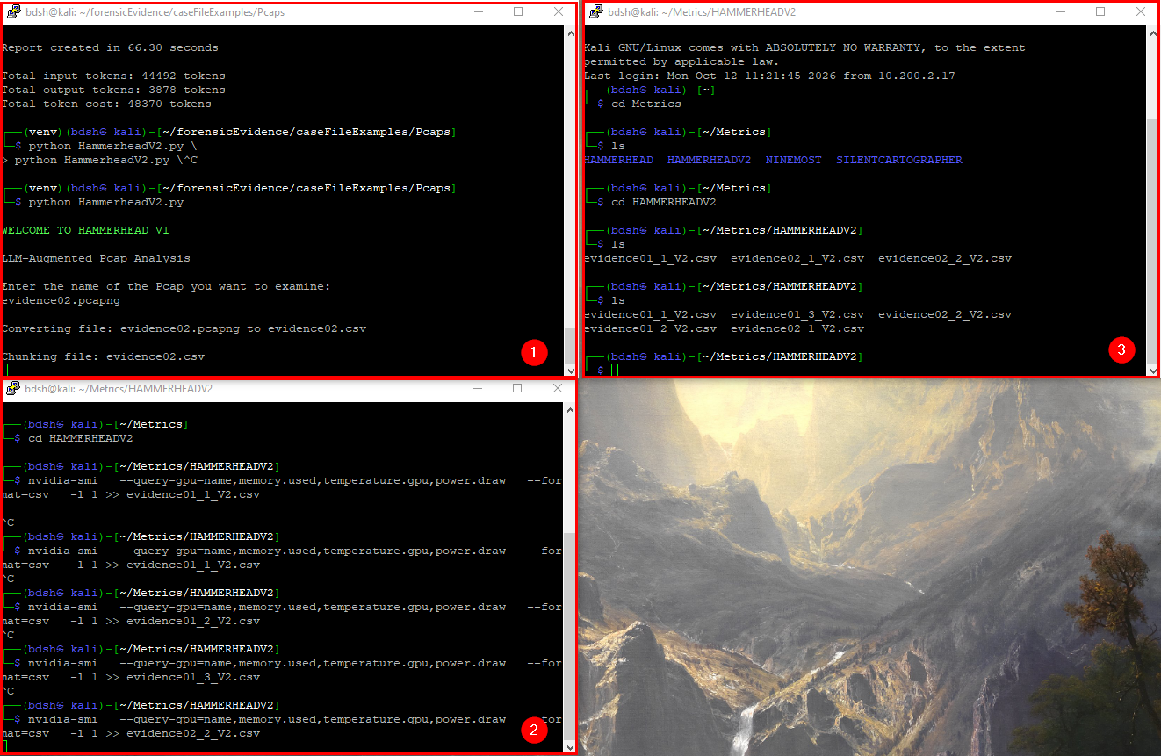

Testing

Development
Monday, 12 October
12:30 – 1:45PM (1hr 15min)
Designing a team logo, Olivia and I are coming up with concepts



